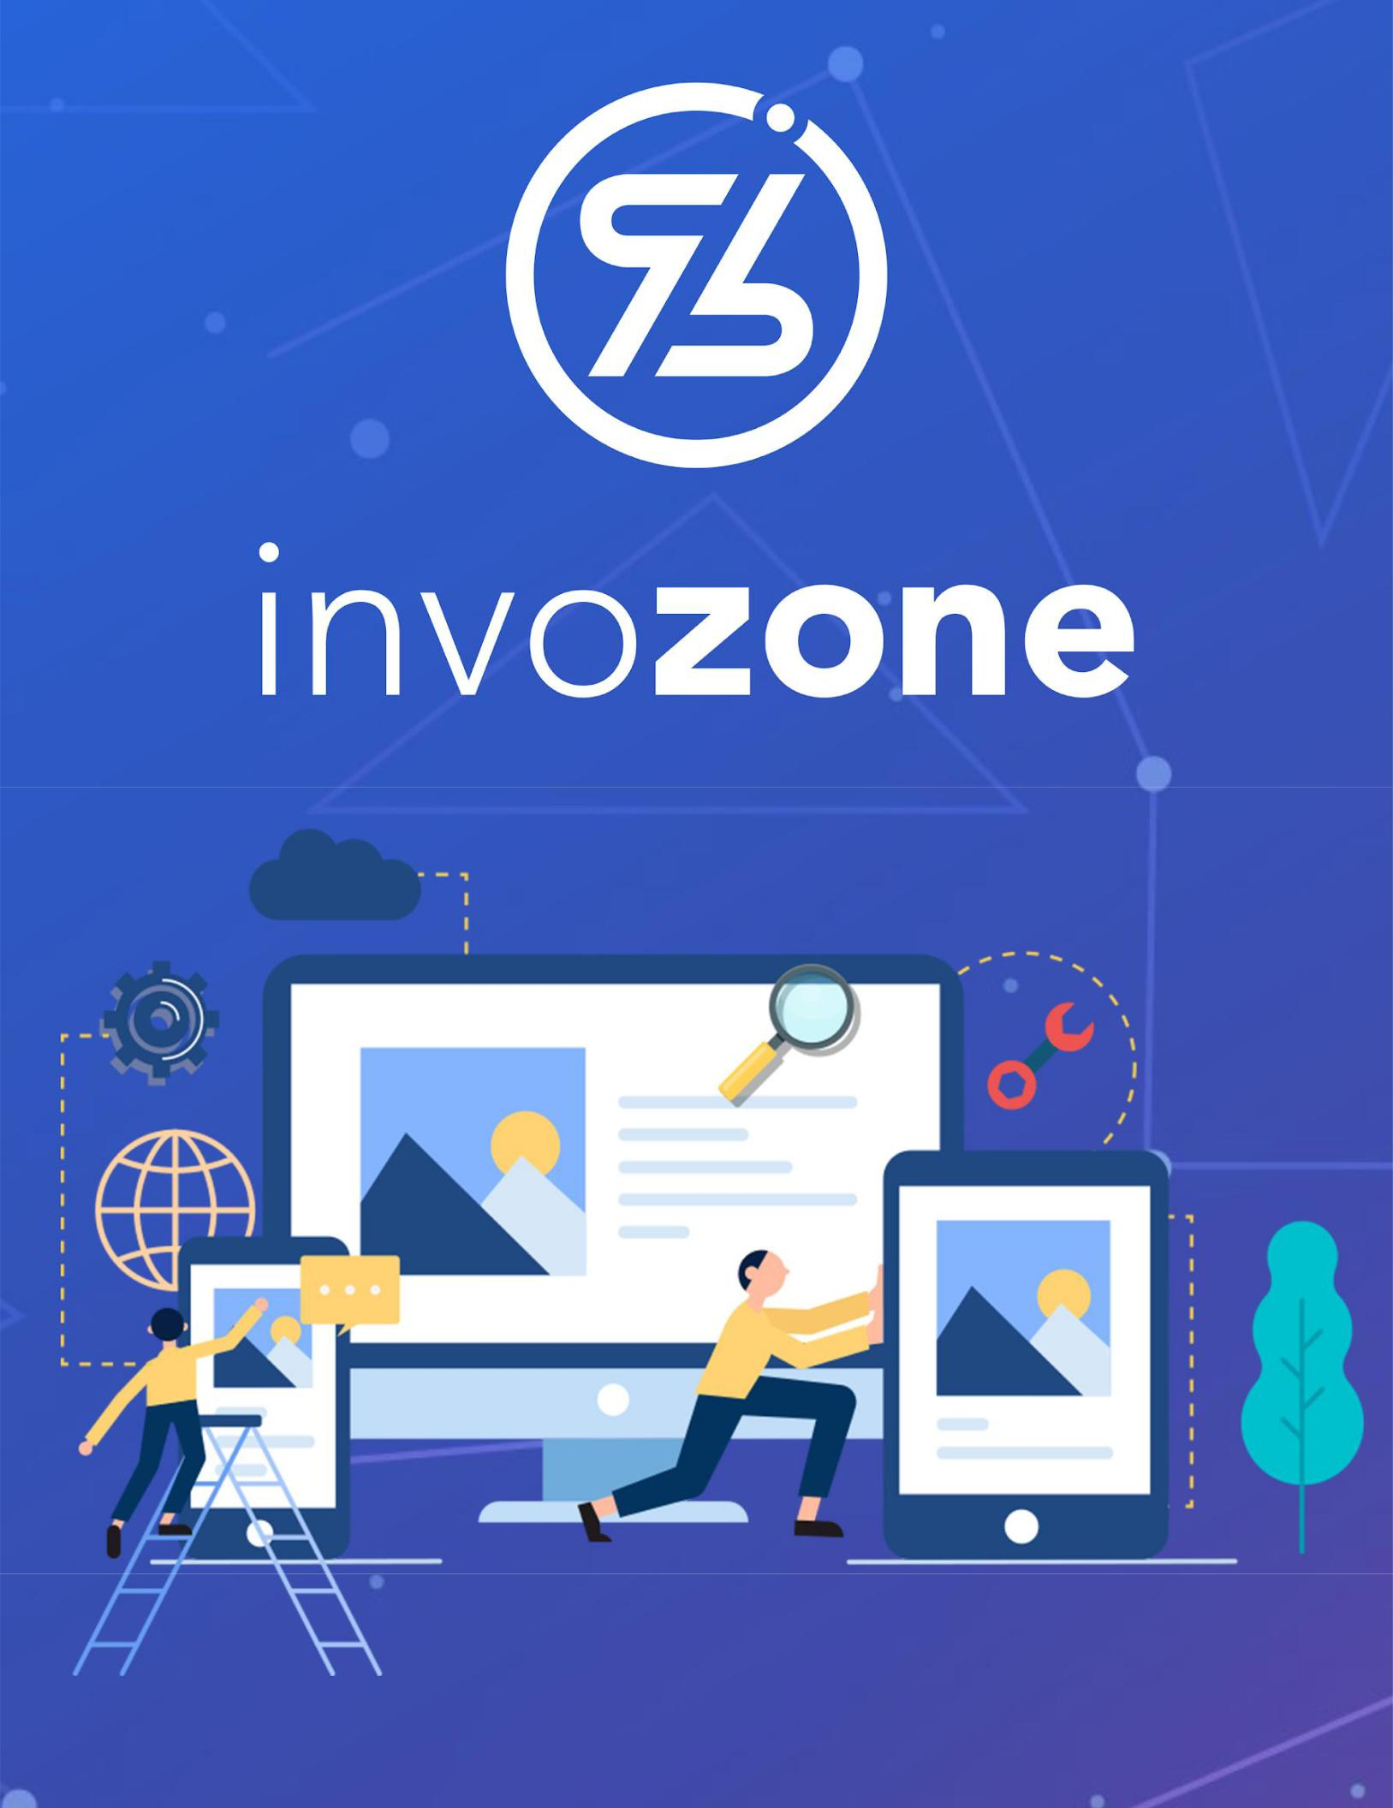

ICO

PRACTICE TASK 5

## January 27, 2022

ERC20 Tokens that you generated in the last exercise is a cryptocurrency and can be used anywhere in any crypto use case. The ERC20 token can be used as a payment facilitator, investments, staking, crowdfunding and many more. For this practice exercise, we will be following one of the most implemented use cases of the blockchain in the initial days of the blockchain boom, that is ICO.

It is better to go through the below reading for better understanding of the process.

**ICO**

(Crowdfunding is a way to raise money from a large number of people. In banking terms it is called IPO (Initial Public Offerings), where new or established companies offer ‘shares’ of their companies to the public, and the funding received is used for the development of the business on profit sharing basis with the shareholders.)

**I**nitial **C**oin **O**ffering - ICO, is a decentralized way of going for crowdfunding. Unlike IPO, ICO is not regulated (by any authorized organization - like bank, or government), rather it is totally decentralized and anonymous, because of which there were more ICO frauds then actual ICOs in the initial years of blockchain.

To cope up with the issues relating to ICO and frauds certain derived methods were derived, explained as below. We will only be going through ICO, however.

* **ICO - Initial Coin Offering**

Very similar to an IPO, except that it is held on-chain and is not regulated. Anyone can develop an ICO for themselves and get fundings. Unlike IPO ICOs usually do not share profits, rather the token owners earn when token price increases as a result of team efforts.

* **STO - Security Token Offering**

Security Tokens (The Howey Test)

STO in structure is exactly the same as ICO (by structure I mean the development modules and features). However, at the back stage, the tokens have to follow certain rules, they have to be registered with federal security laws and have to pass the Howey Test. They work exactly the same as shares, are much safer than ICOs. Profit sharing is involved.

Tokens conforming with howey test, and regulations are called security tokens.

* **IEO - Initial Exchange Offering**

In order to eliminate the problems of random ICO scams and frauds, some notable exchanges jumped in as middle man to include a factor of trust and escrow for crypto crowdfundings.

Crowdfunding held through an Exchange involved are IEOs.

* **IDO - Initial DEX Offering**

Similar to IEO, but is held on Decentralized exchanges rather than centralized ones.

## ICO Implementation

In this tutorial series you will be developing an ICO Contract, using OpenZeppelin, with following functions.

* Minted
* Capped Crowdsale
* Timed
* Whitelisted
* Vesting

<https://youtu.be/2IqsgSyA8BQ?list=PLS5SEs8ZftgULF-lbxy-is9x_7mTMHFIN>

You have to implement the complete playlist of 13 videos. (Do not skip the token videos)